Stalling
Available

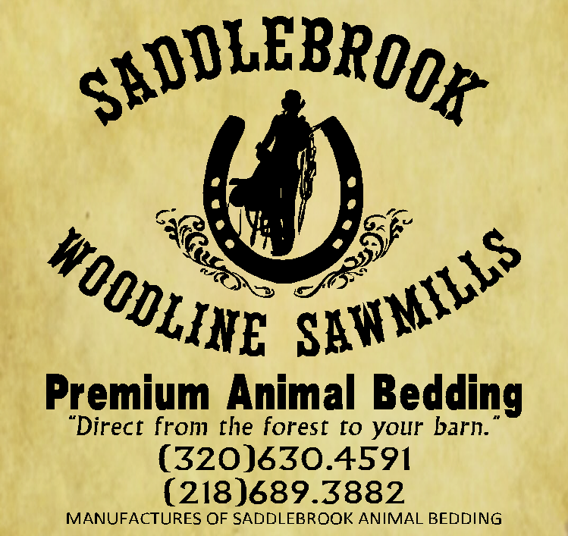
Indoor/Outdoor
Arenas

Water on Grounds

Plenty of Parking

North Metro Association Show

NORTHWEST SADDLE CLUB
26950 Lyons Street NE, North Branch, MN 55056

All Pleasure Show
Saturday October 12th, 2019
8:00 a.m.
WSCA Approved Judge: Roy Johnson
BUCKLE High Point awards
& other prize giveaways

Buckle
Hi-Points
Prizes & Drawings

1st -6th Place Ribbons
1. | Open Driving | 24. | English Pleasure 18-34
2. | Open Halter | 25. | English Pleasure 35-49
3. | Open Weanling/ Yearling Halter | 26. | English Pleasure 50 & Over
4. | Open Yearling Longe Line | 27. | Walk Trot English Pleasure 11 & Under
5. | Showmanship 13 & Under | 28. | Walk Trot English Pleasure 12 & over
6. | Showmanship 14-17 |  | Lunch Break & Royalty Rides
7. | Showmanship 18-34 | 29. | Walk Trot Western horsemanship 11 & under
8. | Showmanship 35-49 | 30. | Walk Trot Western Horsemanship 12 & Over
9. | Showmanship 50 & Over | 31. | Western Horsemanship 13 & under
10. | Bareback 17 & Under | 32. | Western Horsemanship 14-17
11. | Bareback 18 & Over | 33. | Western Horsemanship 18-34
12. | Leadline 6 & Under English Pleasure /English Equitation | 34. | Leadline 6 & Under Western Pleasure/Horsemanship
13. | English Equitation 13 & Under | 35. | Western Horsemanship 35-49
14. | English Equitation 14-17 | 36. | Western Horsemanship 50 & Over
15. | English Equitation 13 & Under | 37. | Walk Trot Western Pleasure 11 & Under
16. | ^{English Equitation 14-17} | 38.. | Walk Trot Western Pleasure 12 & Over
17. | English Equitation 18-34 | 39. | Western Pleasure 13 & Under
18. | English Equitation 35 -49 | 40. | Western Pleasure 14- 17
19. | English Equitation 50 & Over | 41. | Western Pleasure 18-34
20. | Walk Trot English Equitation11 & Under | 42. | Western Pleasure 35-49
21. | Walk Trot English Equitation 12 & Over | 42. | Western Pleasure 50 & Over
22. | English Pleasure 13 & Under | 43. | Open Yearling In Hand Trail
23. | English Pleasure 14-17 | 44. | Open Trail
ENTRY FEES:
$5.00 Office Fee $5.00 per event
WSCA rules apply to ALL classes. NWSC reserves the right to combine, add or remove classes.
Negative Coggins required.
**Entries in Walk-Trot classes are ineligible to ride in loping classes. **
¹ Non-Qualifying For WSCA Championship Show – ²Entries in leadline or RWD classes.
For more information Call/Text: Amanda Kamstra 651-329-4266

